**Regex Lesson**

Referene:   
<https://developer.mozilla.org/en-US/docs/Web/JavaScript/Guide/Regular_Expressions>

<https://developer.mozilla.org/en-US/docs/Web/JavaScript/Guide/Regular_Expressions/Character_Classes>

<https://regex101.com/>

Sintaxa!

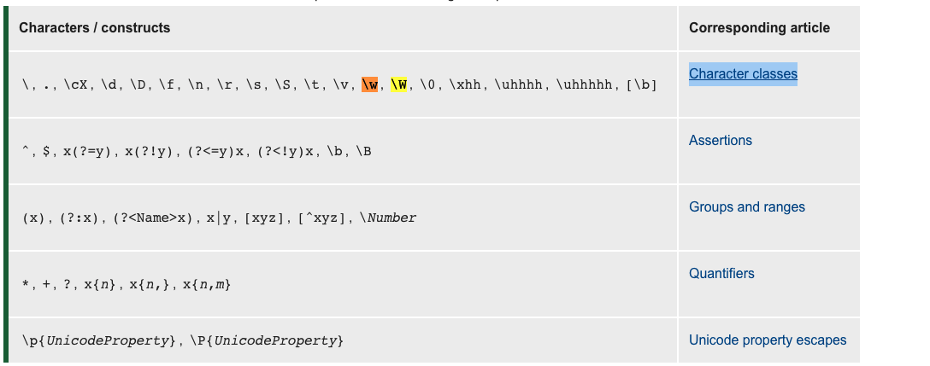

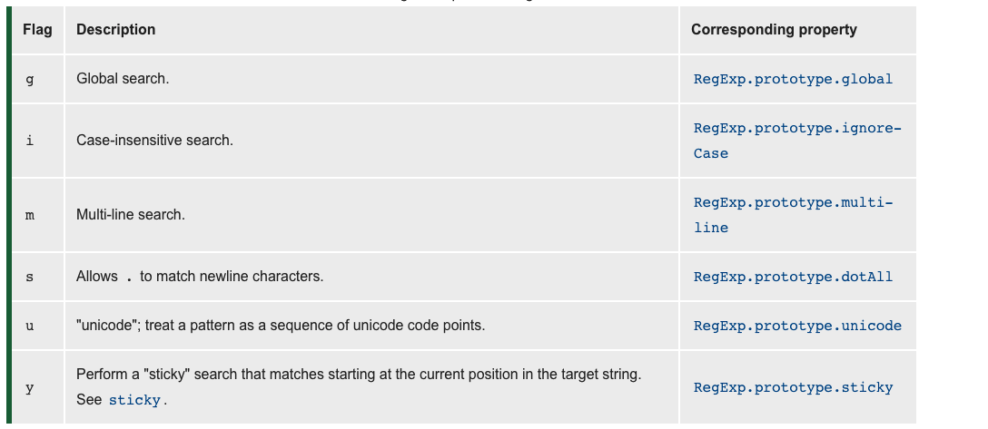

Metode

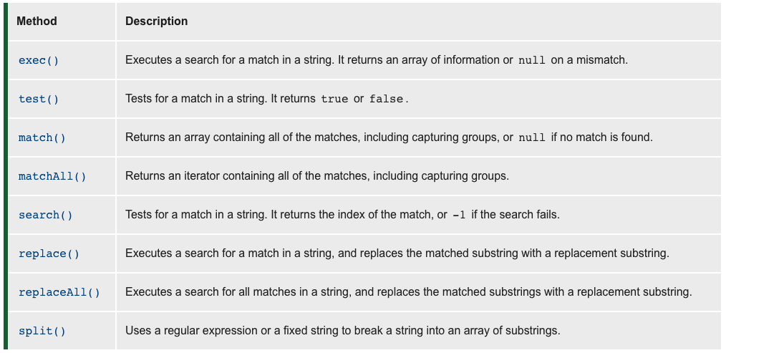

**Exercitii:**

1. <https://www.hackerrank.com/challenges/matching-specific-string/problem> +++
2. <https://www.hackerrank.com/challenges/matching-digits-non-digit-character/problem> +++
3. <https://www.hackerrank.com/challenges/matching-word-non-word/problem> +++
4. <https://www.hackerrank.com/challenges/matching-start-end/problem> +++
5. <https://www.hackerrank.com/challenges/matching-x-y-repetitions/problem> +++
6. <https://www.hackerrank.com/challenges/split-number/problem>+++
7. <https://www.hackerrank.com/challenges/detect-html-tags/problem>+++
8. <https://www.hackerrank.com/challenges/html-attributes/problem> +
9. <https://www.hackerrank.com/challenges/detect-html-links/problem>+
10. <https://www.hackerrank.com/challenges/detect-the-email-addresses/problem>+++
11. <https://www.hackerrank.com/challenges/detect-the-domain-name/problem>
12. <https://www.hackerrank.com/challenges/ide-identifying-comments/problem>